Graphing Radical Functions, Radical Equations and Extraneous Roots, Solving Equations Containing Two Radicals
You are on a team of architects. You are charged with building a scale-model replica of one section of a new roller coaster before construction gets underway.
Certain reinforcement cables and struts are required to make the roller coaster sturdier. The goal for this project is for your team to determine where to place these cables or struts. The mathematical models for these reinforcements are known.
Your team must provide both algebraic and graphical evidence for your conclusions regarding the location of the cables.

Directions:
Complete each of the following tasks, reading the directions carefully as you go. Be sure to show all work where indicated and to insert images of graphs when needed. Make sure that all graphs or screenshots include appropriate information, such as titles and labeled axes. Use the built-in Equation Editor to type equations with mathematical symbols that can’t be typed from the keyboard.
You will be graded on the work you show, or on your solution process, in addition to your answers. Make sure to show all of your work and to answer each question as you complete the task. Type all of your work into this document so you can submit it to your teacher for a grade. You will be given partial credit based on the work you show and the completeness and accuracy of your explanations.
Your teacher will give you further directions as to how to submit your work. You may be asked to upload the document, e-mail it to your teacher, or hand in a hard copy.
The shape of this particular section of the rollercoaster is a half of a circle. Center the circle at the origin and assume the highest point on this leg of the roller coaster is 30 feet above the ground.

- Write the equation that models the height of the roller coaster.

Start by writing the equation of the circle. (Recall that the general form of a circle with the center at the origin is x² + y² = r². (10 points)
Xx+yy=900

Now solve this equation for y. Remember the roller coaster is above ground, so you are only interested in the positive root. (10 points)
Y=|root(900-xx)|

- Graph the model of the roller coaster using the graphing calculator. Take a screenshot of your graph and paste the image below, or sketch a graph by hand. (5 points)

Model 1: One plan to secure the roller coaster is to use a chain fastened to two beams equidistant from the axis of symmetry of the roller coaster, as shown in the graph below:
30
25
20
15
10
5
30
20
10
10
20
30

You need to determine where to place the beams so that the chains are fastened to the rollercoaster at a height of 25 feet.

- Write the equation you would need to solve to find the horizontal distance each beam is from the origin. (10 points)
25=|root(900-xx)|

- Algebraically solve the equation you found in step 3. Round your answer to the nearest hundredth. (10 points)
25=root(900-xx)
625=900-xx
Xx=275
X=16.58

- Explain where to place the two beams. (10 points)
16.58 feet from the center

Model 2: Another plan to secure the roller coaster involves using a cable and strut. Using the center of the half-circle as the origin, the concrete strut can be modeled by the equation and the mathematical model for the cable is. The cable and the strut will intersect.

- Graph the cable and the strut on the model of the roller coaster using the graphing calculator. Take a screenshot of your graph and paste the image below, or sketch a graph by hand. (5 points)
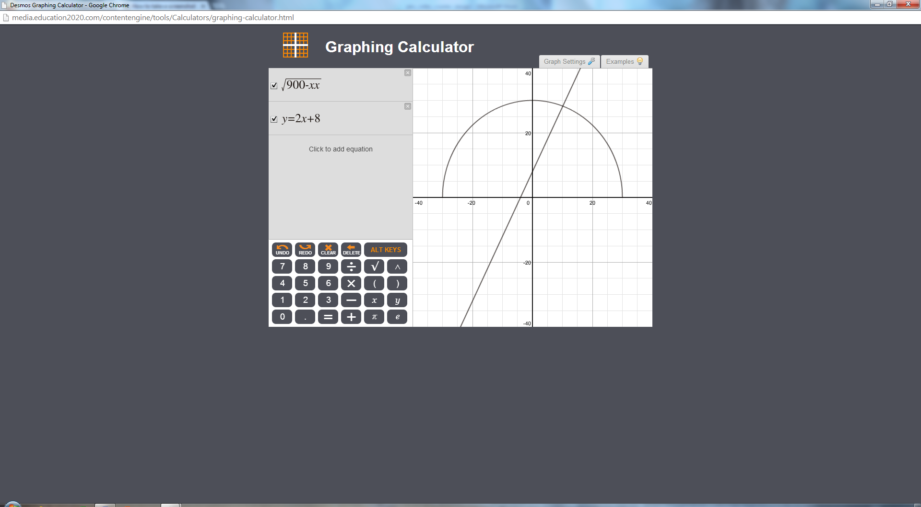

- Algebraically find the point where the cable and the strut intersect. Interpret your answer. (10 points)
2x+8=root(900-xx)
4xx+32x+64=900-xx
3xx+32x-836=0
X=2
Model 3: Another plan to secure the roller coaster involves placing two concrete struts on either side of the center of the leg of the roller coaster to add reinforcement against southerly winds in the region. Again, using the center of the half-circle as the origin, the struts are modeled by the equations and. A vertical reinforcement beam will extend from one strut to the other when the two cables are 2 feet apart.
- Graph the two struts on the model of the roller coaster. Take a screenshot of your graph and paste the image below, or sketch a graph by hand. (5 points)
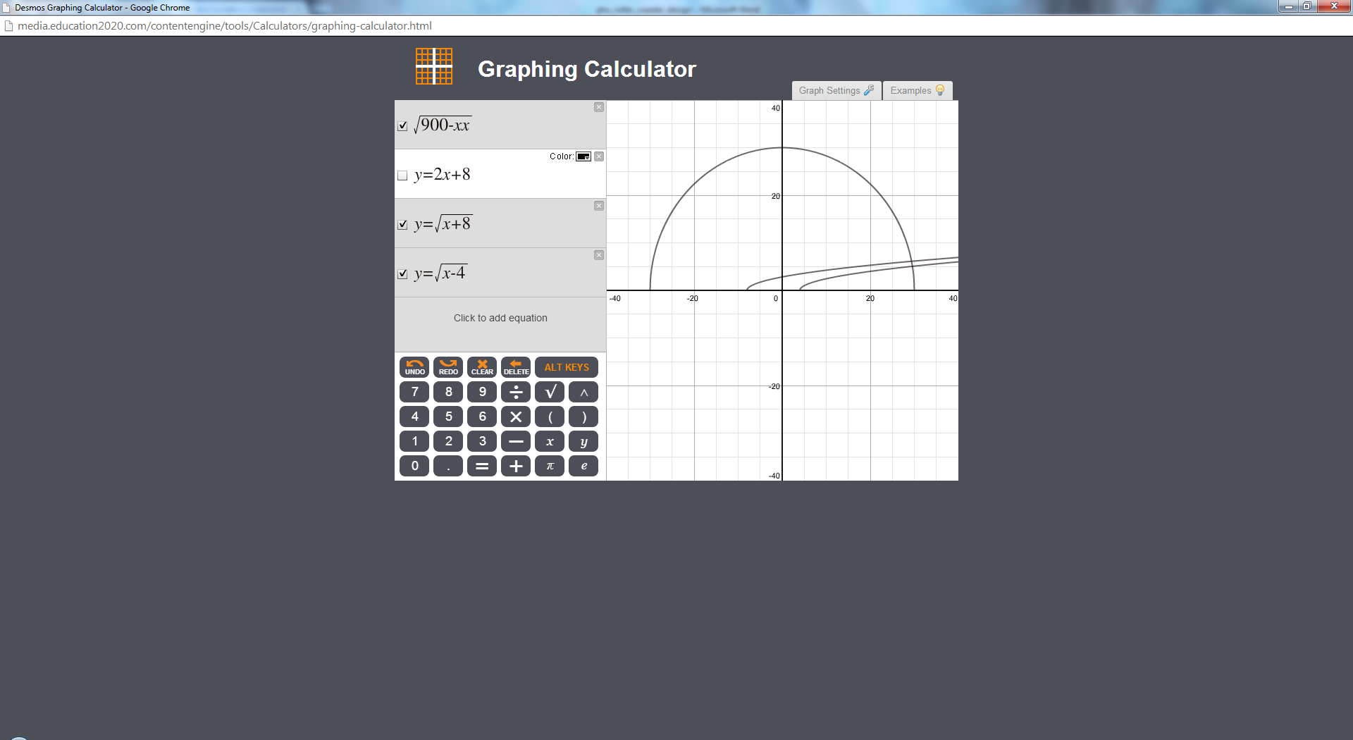

Recall that a reinforcement beam will extend from one strut to the other when the two struts are 2 feet apart.

- Algebraically determine the x -value of where the beam should be placed. (15 points)
X=-4

- Explain where to place the beam. (10 points)
Place the beam directly above 4 feet from the center

